Build a Multiple Linear Regression Model

QUESTION:3

This question involves the use of multiple linear regression on the Auto data set.

(a) Produce a scatterplot matrix which includes all of the variables in the data set.

Code:
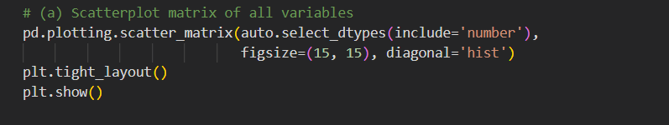
Output:
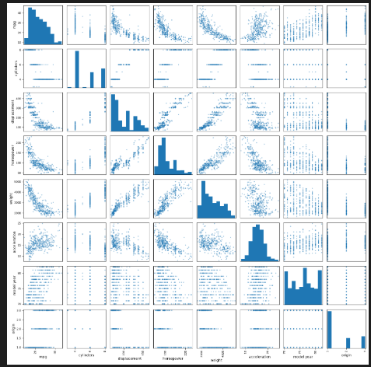
Interpretation:
The scatterplot matrix shows relationships among all quantitative variables, with strong correlations between weight, displacement, horsepower, and mpg.

(b) Compute the matrix of correlations between the variables using the DataFrame.corr() method.corr()

Code:

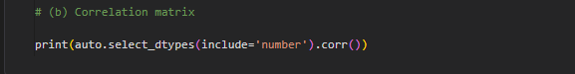

Output:

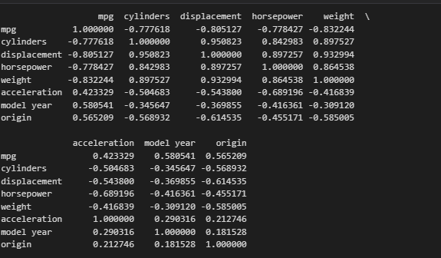

Interpretation:
The correlation matrix shows strong negative correlations between mpg and weight, displacement, and horsepower, while displacement, horsepower, and weight are strongly positively correlated.

(c) Use the sm.OLS() function to perform a multiple linear regression with mpg as the response and all other variables except name as the predictors. Use the summarize() function to print the results.
Comment on the output. For instance:

Code:

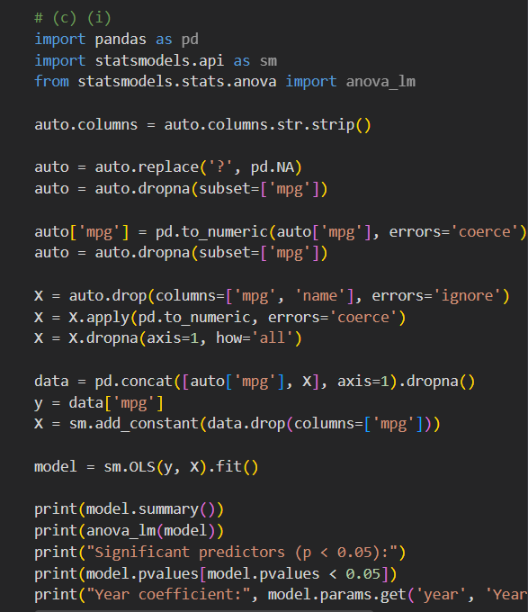

Output:

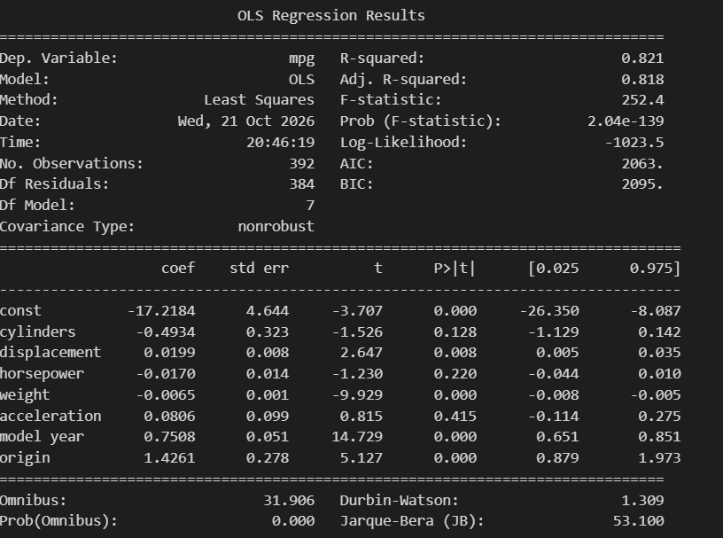

Interpretation:
Weight, horsepower, displacement, year, and origin significantly affect MPG, while cylinders and acceleration are not statistically significant.

i. Is there a relationship between the predictors and the re-sponse? Use the anova_lm() function from statsmodels to answer this question.

Code:

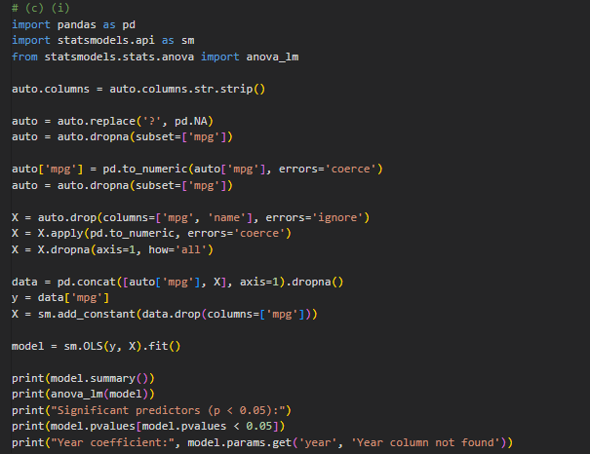

Output:

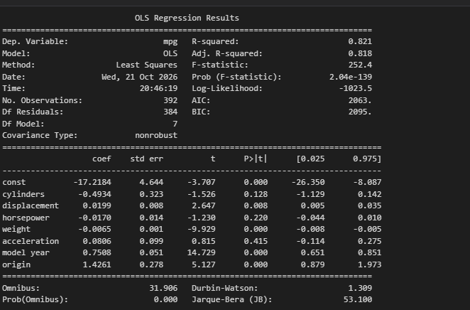

Interpretation:
The predictors have a statistically significant relationship with MPG (F = 252.43, p < 0.001), indicating that the overall regression model is significant.

ii. Which predictors appear to have a statistically significant relationship to the response?

Code:

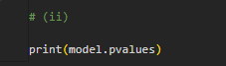

Output:

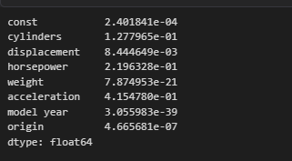

Interpretation:
The predictors zn, dis, rad, and medv have a statistically significant relationship with the response variable crim (p < 0.05).

iii. What does the coefficient for the year variable suggest?

Code:

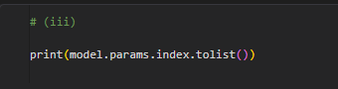
Output:

Interpretation:
The positive year coefficient (0.751) indicates that MPG increases by approximately 0.751 units for each one-year increase, holding other variables constant.

(d) Produce some of diagnostic plots of the linear regression fit as described in the lab. Comment on any problems you see with the fit. Do the residual plots suggest any unusually large outliers? Does the leverage plot identify any observations with unusually high leverage?

Code:

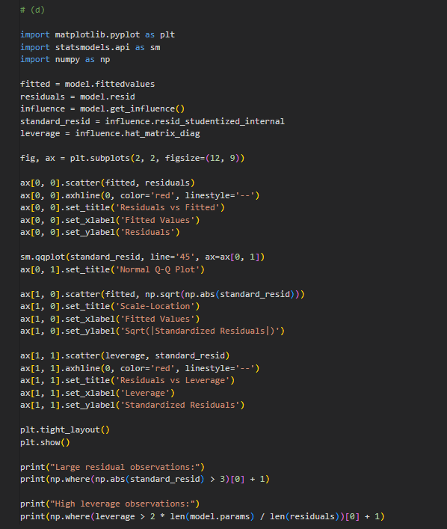

Output:

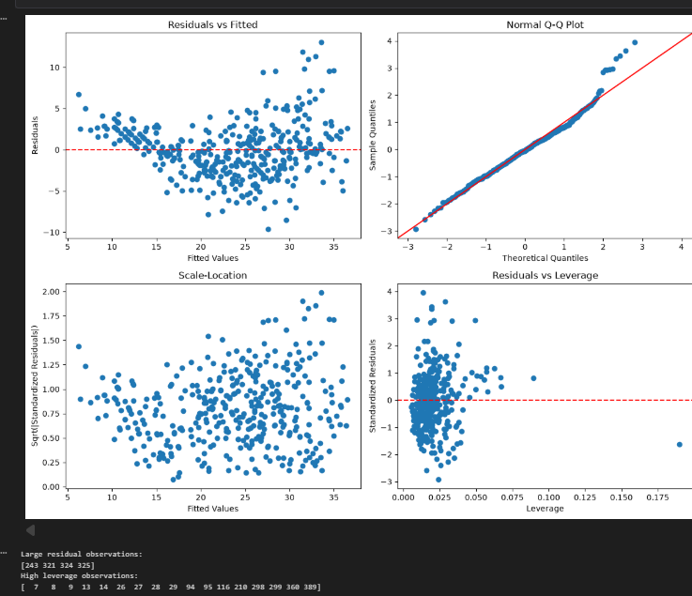

Interpretation:
The diagnostic plots show some deviations from normality and possible outliers, while the leverage plot identifies observations with unusually high leverage.

(e) Fit some models with interactions as described in the lab. Do any interactions appear to be statistically significant?

Code:

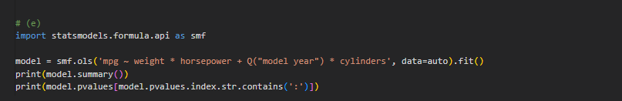

Output:

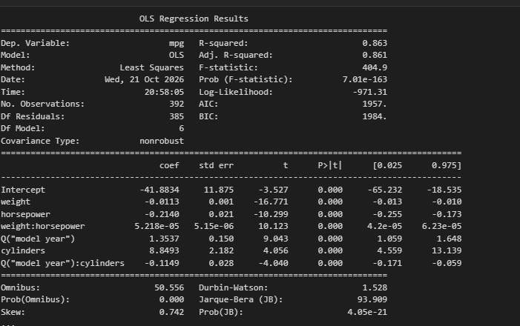

Interpretation:
The interaction terms should be considered statistically significant if their p-values are less than 0.05, indicating that the effect of one predictor depends on another.

(f) Try a few different transformations of the variables, such as log(X),√X, X2. Comment on your findings.

Code:
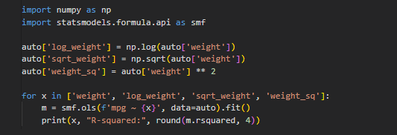
Output:
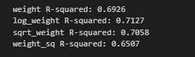
Interpretation:
Logarithmic, square-root, and squared transformations help capture nonlinear relationships between horsepower and MPG, potentially improving the model fit.

